Acceptance Test Procedure

Results (SKYDOC-XXXX)

For

Skyryse Flight OS LEMA TPX 325

Software Version: 1918900-0.9.4.121

|  |  |  |  |  |
| --- | --- | --- | --- | --- |
| LEMA Assembly Part Number | Operator | Condition | Serial Number | Test Start Time |
| LEMA | Hayden | Engineering | 0001 | 5/22/2023 10:38:42 AM |

|  |  |  |
| --- | --- | --- |
| **Summary of Test Results:** | **Fail** | |
|  | | |
| **Requirements** | **Pass/Fail** | |
| **6.1 Visual Examination of the Product** | **Pass** | |
| **6.2 Weight** | **Pass** | |
| **6.3 Bonding** | **Fail** | |
| **6.4 Resistance and Inductance Test (motor and Solenoid)** | **Fail** | **Fail** |
| **6.5 Power ON UUT Checks** | **Pass** | |
| **6.6 Functional Check Out** | **Pass** | |
| **6.6.3 Holding Load Test** | **Fail** | **Fail** |
| **6.6.4 Brake Release** | **Pass** | |
| **6.6.5 N1 and N2 Extend Mechanical Stops and MCE Rigging** | **Fail** | |
| **6.6.6 N1 and N2 Stroke** | **Fail** | |
| **6.6.7 Performance Test – unloaded operation (one channel operation)** | **Fail** | |
| **6.6.8 Performance Test – Loaded Operation** | **Fail** | |
| **6.6.9 Backlash** | **Fail** | |

**Table of Units**

|  |  |
| --- | --- |
| **Unit** | **Abbreviation used** |
| Pounds | lbs. |
| Milliohms | mOhms |
| Ohms | Ohms |
| MilliHertz | mHz |
| Hertz | Hz |
| Inches | in |
| Pounds of force | lbf |
| Ampheres | A |
| Bit values in Hexadecimal | Code |
| Inches per Second | in/s |
| Milliseconds | ms |
| Seconds | seconds |
| Decibel | dB |
| Degrees | deg |
| Tolerance in the range of | +/- |

**6.1. Visual Examination of the Product**

|  |  |
| --- | --- |
| UUT conforms to the requirements of paragraph 6.1 | Pass |

**6.2 Weight**

|  |  |  |  |
| --- | --- | --- | --- |
| **UUT Weight** | | | |
| **Requirements** | **Results** | | |
| **UUT weight should not exceed** | **Actual Weight** | **Units** | **Pass/Fail** |
| 10 | 9 | lbs. | Pass |

6.3 Bonding

**Bonding resistance:**

|  |  |  |  |  |  |
| --- | --- | --- | --- | --- | --- |
| **Bonding Resistance** | | | | | |
| **Requirements** | | | **Results** | | |
|  | **Expected** | **Tolerance** | **Simplex** | **Duplex** | **Units** |
| Motor End Cap | 10 | 0.5 | 10 | 9.8 | (mOhms) |
| Solenoid housing | 10 | 0.5 | 9.4 | 9.51111 | (mOhms) |
| Encoder cover | 7.5 | 0.5 | 8 | 7.6 | (mOhms) |
| All Bonding Pass/Fail | | | Fail | |  |

**6.4 Resistance and Inductance Test** **(motor and solenoid)**

**Resistances:**

|  |  |  |  |  |  |  |
| --- | --- | --- | --- | --- | --- | --- |
| **Motor and Solenoid Resistances** | | | | | | |
| **Requirements** | | | **Results** | | | |
| Pins | **Expected** | **Tolerance** | **Connector J1** | **Connector J2** | **Connector J3** | **Units** |
| E to F | 0.212 | 0.0212 | 4 | 5 | 6 | (Ohms) |
| F to G | 0.212 | 0.0212 | 10 | 3 | 4.5 | (Ohms) |
| G to E | 0.212 | 0.0212 | 9.8 | 10 | 8 | (Ohms) |
| A to L | 6.55 | 0.44 | 45 | 5 | 6 | (Ohms) |
| G,F,E,A,L tied together to chassis grounds. Apply 500VDC | 5000000 | 0 | 1 | 0 | 5 | (Ohms) |
| All Resistances Pass/Fail | | | Fail | | |  |

**Inductances:**

|  |  |  |  |  |  |  |
| --- | --- | --- | --- | --- | --- | --- |
| **Motor and Solenoid Inductances** | | | | | | |
| **Requirements** | | | **Results** | | | |
|  | **Expected** | **Tolerance** | **Connector J1** | **Connector J2** | **Connector J3** | **Units** |
| E to F | 0.155 | 0.02325 | 6 | 8 | 2 | (mHz) |
| F to G | 0.155 | 0.02325 | 5 | 6 | 6 | (mHz) |
| G to E | 0.155 | 0.02325 | 8 | 2 | 3 | (mHz) |
| A to L | 22 | 3.3 | 1 | 8 | 10 | (mHz) |
| All Inductances Pass/Fail | | | Fail | | |  |

**6.5 Power ON UUT Checks**

Confirm all sensors are reporting nominal values and no faults reported

|  |  |  |  |
| --- | --- | --- | --- |
| **Power ON UUT Checks** | | | |
| **Description** | **Results** | | |
| **Sensor** | **Value** | **Units** | **Pass/Fail** |
| Motor 1 | -0.0100 | in | Pass |
| Motor 2 | -0.0100 | in | Pass |
| Motor 3 | -0.0160 | in | Pass |
| M1 | 0.0000 | in | Pass |
| M2 | 0.0000 | in | Pass |
| M3 | 0.0000 | in | Pass |
| Faults 1 | 400 | Code | Pass |
| Faults 2 | 400 | Code | Pass |
| Faults 3 | 400 | Code | Pass |

**6.6 Functional Check Out**

**6.6.1 MCE1, MCE 2, MCE3 Power Up**

|  |  |  |  |  |
| --- | --- | --- | --- | --- |
| **Functional Check Out** | | | | |
| **Requirements** | **Results** | | | |
| **Description** | **Ballnut position** | **Units** | **Pass/Fail** | |
| MCE 1 reports values for Ballnut position and motor current | -0.0002 | in | Ballnut Position | Current |
| Pass | Pass |
| (Simulated) FCC/reports values for M1(QPS) | -0 | in | Pass |  |
| MCE 2 reports values for Ballnut position and motor current | -0 | in | Pass | Pass |
| (Simulated) FCC/reports values for M2(QPS) | -0 | in | Pass |  |
| MCE 3 reports values for Ballnut position and motor current | -0.0029 | in | Pass | Pass |
| (Simulated) FCC/reports values for M3(QPS) | -0.0001 | in | Pass |  |

**6.6.3 Holding Load Test**

**6.6.3.1 Brake OFF, LEMA Output Locked**

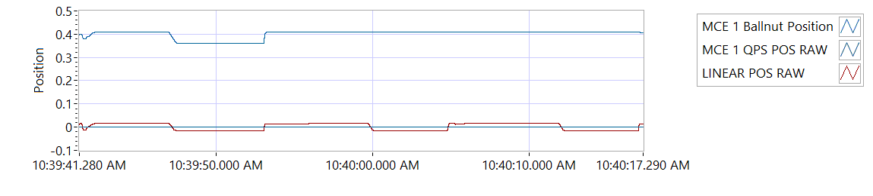

Figure -Hold Brake OFF for MCE 1

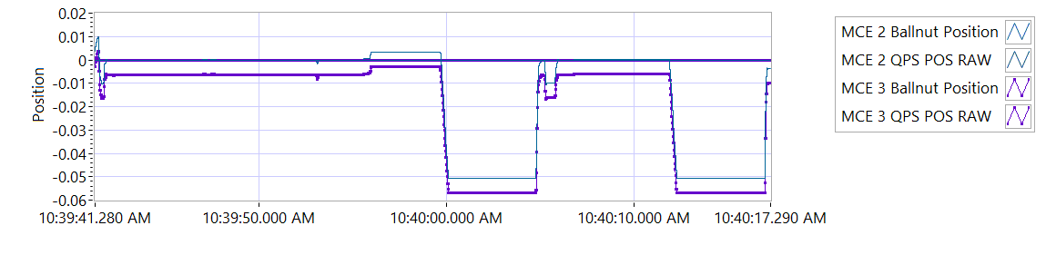

Figure -Hold Brake OFF for MCE 2

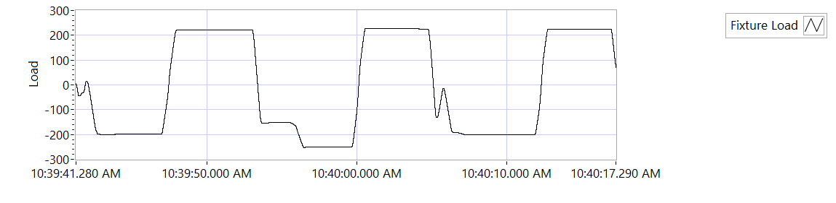

Figure -Hold Brake OFF for MCE 3

|  |  |  |  |  |  |
| --- | --- | --- | --- | --- | --- |
| **Holding Load Test - Brake OFF, LEMA Output Locked** | | | | | |
| **Requirements** | | | **Results** | | |
| **MCE** | **Expected Output Force/Amps** | **Tolerance** | **Actual Output force/Amps** | **Units** | **Output force/Amps, Pass/Fail** |
| MCE 1, 6.6.3.1.1 step d/e– extend 0.4 in, Sustain 12.6 Amps (TBC) current limit for 3-5 seconds | 562.5 | 237.5 | -197.8936 | lbf | Failed |
| 12.6 | 8.0 | 5.9862 | A | Pass |
| MCE 1, 6.6.3.1.1 step f/g - retract 0.4 in, Sustain 12.6 Amps (TBC) current limit for 3-5 seconds | 562.5 | 237.5 | 219.1794 | lbf | Failed |
| -12.6 | 8.0 | -6.0149 | A | Pass |
| MCE 2, 6.6.3.1.2 step d/e– extend 0.4 in, Sustain 12.6 Amps (TBC) current limit for 3-5 seconds | 562.5 | 237.5 | -249.2832 | lbf | Failed |
| 12.6 | 8.0 | 6.0053 | A | Pass |
| MCE 2, 6.6.3.1.2 step f/g - retract 0.4 in, Sustain 12.6 Amps (TBC) current limit for 3-5 seconds | 562.5 | 237.5 | 227.2737 | lbf | Failed |
| -12.6 | 8.0 | -6.0006 | A | Pass |
| MCE 3, 6.6.3.1.3 step d/e– extend 0.4 in, Sustain 12.6 Amps (TBC) current limit for 3-5 seconds | 562.5 | 237.5 | -201.416 | lbf | Failed |
| 12.6 | 8.0 | 6.0068 | A | Pass |
| MCE 3, 6.6.3.1.3 step f/g - retract 0.4 in, Sustain 12.6 Amps (TBC) current limit for 3-5 seconds | 562.5 | 237.5 | 223.1145 | lbf | Failed |
| -12.6 | 8.0 | -5.9955 | A | Pass |

**6.6.3.2 Brake ON, LEMA Output Free**

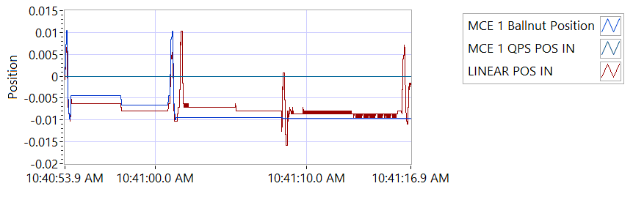

Figure -Hold Brake ON for MCE 1

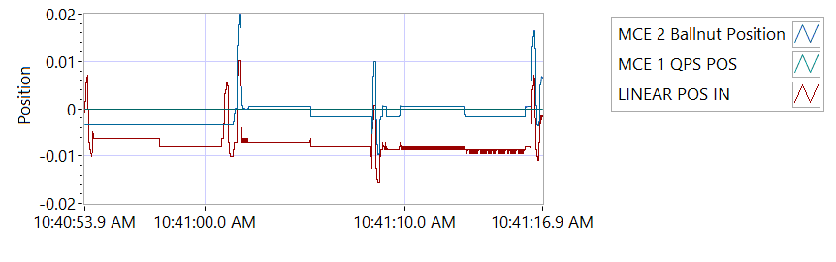

Figure -Hold Brake ON for MCE 2

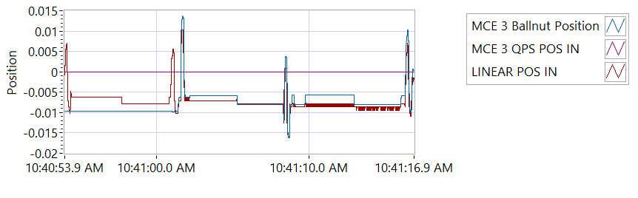

Figure -Hold Brake ON for MCE 3

|  |  |  |  |  |  |  |
| --- | --- | --- | --- | --- | --- | --- |
| **Holding Load Test - Brake ON, LEMA Output Free**  **12.6 +/- 8 Amps for 3-5 seconds** | | | | | | |
| **Requirements** | **Results** | | | | | |
| **MCE** | **MCE Current** | **Units** | **Current Pass/Fail** | **Position feedback** | **Units** | **Position Feedback Pass/Fail** |
| MCE 1, 6.6.3.2.1 step I – extend 0.4 in | 6.003 | A | Pass | -0.0063 | in | Pass |
| MCE 1, 6.6.3.2.1 step k - retract 0.4 in | -5.9963 | A | True | -0.0079 | in | Pass |
| MCE 2, 6.6.3.2.2 step i – extend 0.4 in | 5.9977 | A | True | -0.0071 | in | Pass |
| MCE 2, 6.6.3.2.2 step k - retract 0.4 in | -5.9906 | A | True | -0.0079 | in | Pass |
| MCE 3, 6.6.3.2.3 step I – extend 0.4 in | 5.9937 | A | True | -0.0087 | in | Pass |
| MCE 3, 6.6.3.2.3 step k - retract 0.4 in | -6.0176 | A | True | -0.0087 | in | Pass |

**6.6.4 Brake Release Test**

**Step d – LEMA reaches commanded position.**

|  |  |  |  |  |  |
| --- | --- | --- | --- | --- | --- |
| **Brake Release Test** | | | | | |
| **Requirements** | | | **Results** | | |
| Description | Expected | Tolerance | Position | Units | Pass/Fail |
| MCE1 /Motor 1 | 0.4 | 0.05 | 0.400 | in | Pass |
| MCE2 /Motor 2 | 0.4 | 0.05 | 0.400 | in | Pass |
| MCE3 /Motor 3 | 0.4 | 0.05 | 0.400 | in | Pass |

**6.6.5 N1 and N2 Extend Mechanical Stops and MCE Rigging**

**Step 6.6.5.1** **Extend using M1/N1**

|  |  |  |  |
| --- | --- | --- | --- |
| **Extend using M1/N1** | | | |
| **Requirements** | **Results** | | |
| **Description** | **Value** | **Units** | **Pass/Fail** |
| N1 extend stop engaged (M1 current saturated) | 1024 | Code | Pass |
| MCE 1 Motor Current 4.5 +/- 0.15 Amps | 5.9973 | A | Failed |
| Linear Encoder Value | -0.3219 | in | Pass |
| N1 is Rigged | 0 | Code | Pass |

**Step 6.6.5.2** **Extend using M2/N2**

|  |  |  |  |
| --- | --- | --- | --- |
| **Extend using M2/N2** | | | |
| **Requirements** | **Results** | | |
| **Description** | **Value** | **Units** | **Pass/Fail** |
| N2 extend stop engaged (M2 current saturated) | 1024 | Code | Pass |
| MCE2 Motor Current 4.5 +/- 0.15 Amps | 6.0001 | A | Failed |
| Linear Encoder Value | -0.3494 | in | Pass |
| N2 (Motor 2) is Rigged | 0 | Code | Pass |
| N2 (Motor 3) is Rigged | 0 | Code | Pass |

**6.6.6 N1 and N2 Stroke Check**

|  |  |  |  |  |  |
| --- | --- | --- | --- | --- | --- |
| **N1 and N2 Stroke Check Position** | | | | | |
| **Requirements** | | | **Results** | | |
| **Pin to pin Length** | **Expected** | **Tolerance** | **Pin to Pin Length** | **Units** | **Pass/Fail** |
| 16.732 | 1 | 16.3 | in | Pass |
| **Requirements** | | | **Results** | | |
| **Description** | **Expected** | **Tolerance** | **Actual Position N1/N2** |  | **Pass/Fail** |
| N2 at -0.575 ins from Null using M2 | -0.575 | 0.1 | -0.575 | in | Pass |
| N1 at +1.725 ins from Null using M1 | 1.725 | 0.1 | 1.7249 | in | Pass |
| N1 at -0.575 ins from Null using M1 | -0.575 | 0.1 | -0.575 | in | Pass |
| N2 at +1.725 ins from NULL using M2 | 1.725 | 0.1 | 1.7254 | in | Pass |
| N1 at -0.575 ins from Null using M1 | -0.575 | 0.1 | -0.575 | in | Pass |
| N2 at +1.725 ins from Null using M3 | 1.725 | 0.1 | 1.7255 | in | Pass |
| N2 at -0.575 ins from Null using M3 | -0.575 | 0.1 | -0.5742 | in | Pass |

|  |  |  |  |  |  |
| --- | --- | --- | --- | --- | --- |
| **All Motor Stroke Check Description** | | | | | |
| **Requirements** | | | **Results** | | |
| **Description** | **Expected Difference from Test rig encoder** | **Tolerance** | **Difference from Test rig encoder** | **Units** | **Pass/Fail** |
| Motor 1 position + Motor 2 position = test rig encoder | 0 | 0.1 | 0.0026 | in | Pass |
| Motor1 position + Motor 3 position = test rig encoder | 0 | 0.1 | 0.0026 | in | Pass |
| M1 position + M2 position = test rig encoder | 0.1 | 0.1 | -0.3723 | in | Failed |
| M1 position + M3 position = test rig encoder | 0 | 0.1 | -0.3723 | in | Failed |
| Difference between Motor 2 position and Motor 3 position is < TBD ins | 0 | 0.1 | 0 | in | Pass |
| Difference between M2 position and M3 position is < TBD ins | 0 | 0 | 0 | in | Pass |
| Difference between Motor 1 position and M1 position is < TBD ins | 0 | 0.1 | 0.9499 | in | Failed |
| Difference between Motor 2 position and M2 position is < TBD ins | 0 | 0.1 | 0.575 | in | Failed |
| Difference between Motor 3 position and M3 position is < TBD ins | 0 | 0.1 | 0.575 | in | Failed |

MOTOR 1

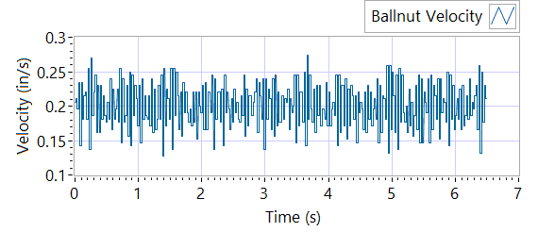

Figure - Ballnut Velocity for Motor One

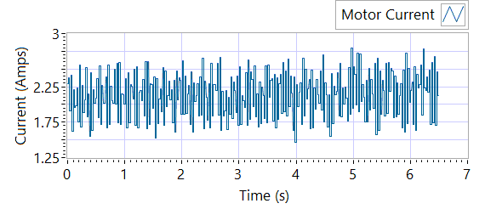

Figure -Current for Motor One

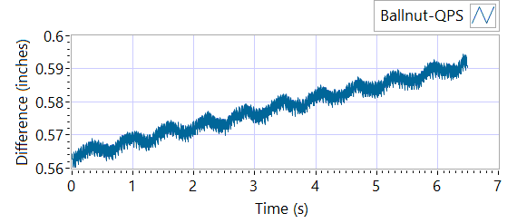

Figure - M1 Delta for Motor One

|  |  |  |  |  |  |  |
| --- | --- | --- | --- | --- | --- | --- |
| **MOTOR 1 STROKE CHECK** | | | | | | |
| **Requirements** | | | **Results** | | | |
| **Description** | **Expected** | **Tolerance** | **Actual Average** | **Peak Velocity** | **Units** | **Pass/Fail** |
| Constant Velocity | 0.2 | 0.02 | 0.2005 | 0.2005 | in/s | Pass |
| **Description** | **Expected** | **Tolerance** | **Actual** | **Standard Deviation** | **Units** | **Pass/Fail** |
| Delta between Motor 1 Position and M1 position | 0.1 | 0.2 | 1.5968 | 0.0081 | in | Failed |
| Delta between Motor 1 Position and Linear Encoder position | 0.1 | 0.2 | 0.5944 | 0.3747 | in | Failed |
| Motor Current |  |  | 2.1312 | 0.3181 | A |  |

MOTOR 2

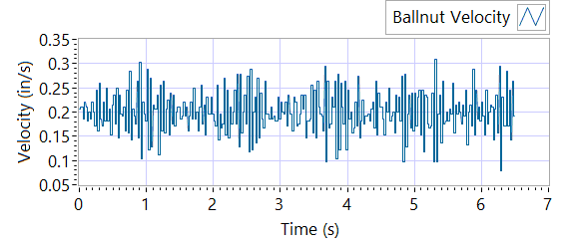

Figure - Ballnut Velocity for Motor Two

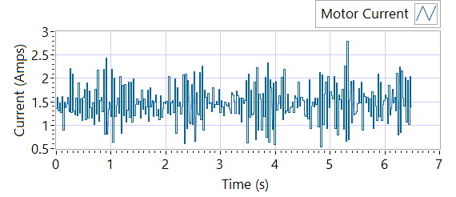

Figure -Current for Motor Two

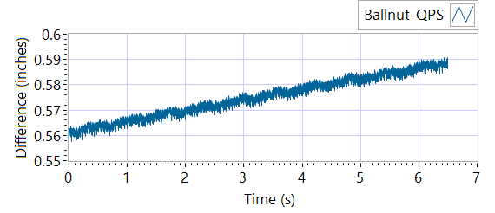

Figure - M1 Delta for Motor Two

|  |  |  |  |  |  |  |
| --- | --- | --- | --- | --- | --- | --- |
| **MOTOR 2 STROKE CHECK** | | | | | | |
| **Requirements** | | | **Results** | | | |
| **Description** | **Expected** | **Tolerance** | **Actual Average** | **Peak Velocity** | **Units** | **Pass/Fail** |
| Constant Velocity | 0.2 | 0.02 | 0.1998 | 0.1998 | in/s | Pass |
| **Description** | **Expected** | **Tolerance** | **Actual** | **Standard Deviation** | **Units** | **Pass/Fail** |
| Delta between Motor 2 Position and M2 position | 0.1 | 0.2 | 1.5984 | 0.0082 | in | Failed |
| Delta between Motor 2 Position and Linear Encoder position | 0.1 | 0.2 | 0.5913 | 0.3748 | in | Failed |
| Motor Current |  |  | 1.4711 | 0.3887 | A |  |

MOTOR 3

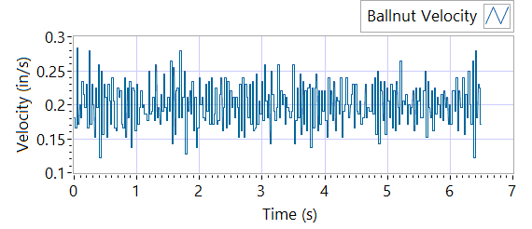

Figure - Ballnut Velocity for Motor Three

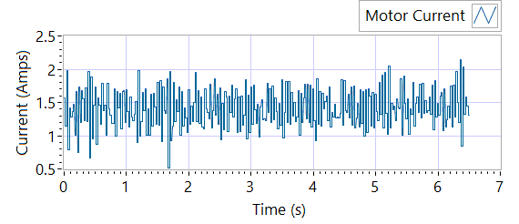

Figure -Current for Motor Three



Figure - M3 Delta for Motor Three

|  |  |  |  |  |  |  |
| --- | --- | --- | --- | --- | --- | --- |
| **MOTOR 3 STROKE CHECK** | | | | | | |
| **Requirements** | | | **Results** | | | |
| **Description** | **Expected** | **Tolerance** | **Actual Average** | **Peak Velocity** | **Units** | **Pass/Fail** |
| Constant Velocity | 0.2 | 0.02 | 0.2003 | 0.2003 | in/s | Pass |
| **Description** | **Expected** | **Tolerance** | **Actual** | **Standard Deviation** | **Units** | **Pass/Fail** |
| Delta between Motor 3 Position and M3 position | 0.1 | 0.2 | 1.587 | 0.0081 | in | Failed |
| Delta between Motor 3 Position and Linear Encoder position | 0.1 | 0.2 | 0.5908 | 0.3754 | in | Failed |
| Motor Current |  |  | 1.4141 | 0.2903 | A |  |

**6.6.7 Performance Test – unloaded operation (one channel operation)**

**6.6.7.1.1 MCE 1 - Step Response Test**

**The result for motor one is shown below:**

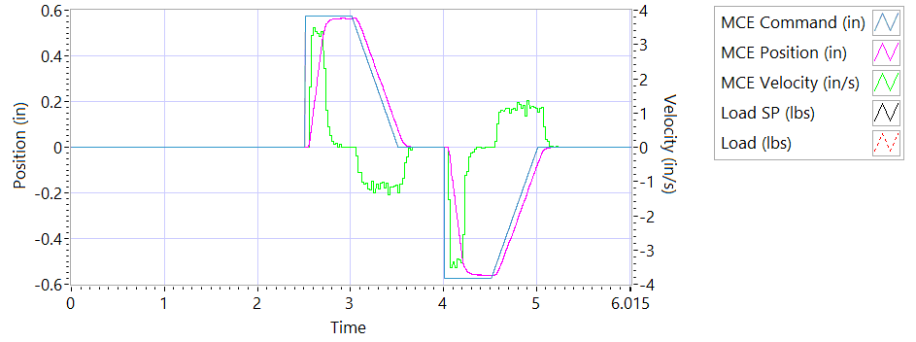

Figure - Results for Motor One

**Step d Extension**

|  |  |  |  |
| --- | --- | --- | --- |
| **MCE 1 - Step Response Extension Unloaded** | | | |
| **Requirements** | **Results** | | |
| **Description** | **Actual Speed / Time** | **Units** | **Pass/Fail** |
| No Load speed is 2.7 to 3.3 in/sec | 3.2686 | in/s | True |
| Time to achieve 80% of the specified stroke (+ 0.575 ins) is 170+9/-9 ms | 0.2059 | seconds | Failed |

**Step e Retraction**

|  |  |  |  |
| --- | --- | --- | --- |
| **MCE 1 - Step Response Retraction Unloaded** | | | |
| **Requirements** | **Results** | | |
| **Description** | **Actual Speed / Time** | **Units** | **Pass/Fail** |
| No Load speed is 2.7 to 3.3 in/sec | -3.2451 | in/s | True |
| Time to achieve 80% of the specified stroke (- 0.575 ins) is 170+9/-9 ms | 0.2041 | seconds | Failed |

**6.6.7..1.2 MCE 1 - Frequency Response**

**Step d**

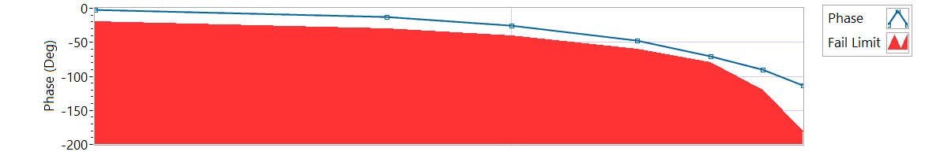

Figure - Phase for Motor One

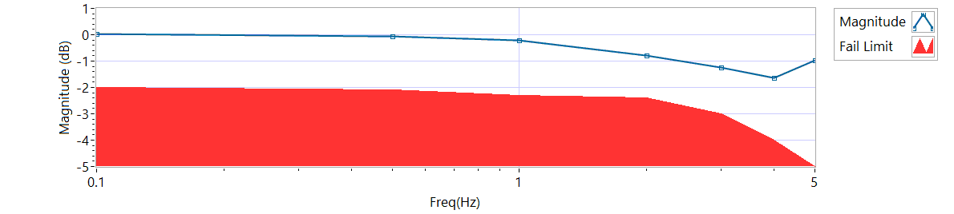

Figure - Magnitude for Motor One

**Frequency Response**

|  |  |  |  |  |
| --- | --- | --- | --- | --- |
| **MCE 1 - Frequency Response Unloaded** | | | | |
| **Frequency**  **(Hz)** | **Magnitude**  **(dB)** | **Phase**  **(deg)** | **Max Phase**  **Allowance (deg)** | **Pass/Fail** |
| 0.1 Hz | 0.0365077 | -2.4192 | -20 | Pass |
| 0.5 Hz | -0.0455638 | -12.42 | -30 | Pass |
| 1 Hz | -0.198074 | -24.912 | -40 | Pass |
| 2 Hz | -0.776381 | -47.952 | -60 | Pass |
| 3 Hz | -1.23678 | -70.308 | -80 | Pass |
| 4 Hz | -1.64483 | -90.432 | -120 | Pass |
| 5 Hz | -0.963057 | -113.04 | -180 | Pass |

6.6.7.2.1 **MCE 2 - Step Response Test**

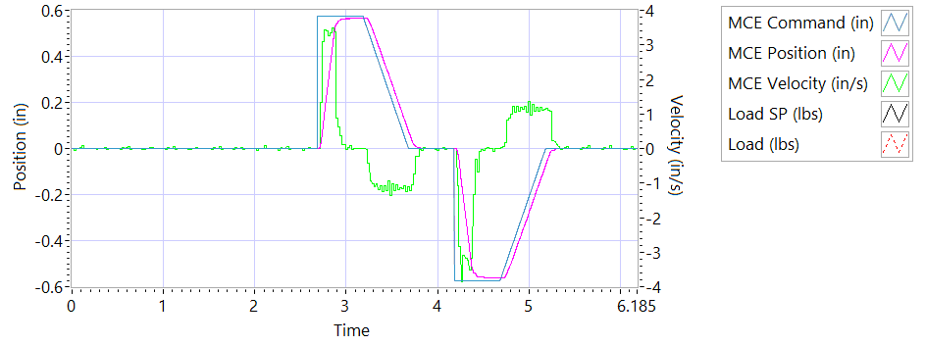

Figure - Results for Motor Two

**Step d Extension**

|  |  |  |  |
| --- | --- | --- | --- |
| **MCE 2 - Step Response Extension Unloaded** | | | |
| **Requirements** | **Results** | | |
| **Description** | **Actual Speed / Time** | **Units** | **Pass/Fail** |
| No Load speed is 2.7 to 3.3 in/sec | 3.2885 | in/s | Pass |
| Time to achieve 80% of the specified stroke (+ 0.575 ins) is 170+9/-9 ms | 0.1977 | seconds | Failed |

**Step e Retraction**

|  |  |  |  |
| --- | --- | --- | --- |
| **MCE 2 - Step Response Retraction Unloaded** | | | |
| **Requirements** | **Results** | | |
| **Description** | **Actual Speed / Time** | **Units** | **Pass/Fail** |
| No Load speed is 2.7 to 3.3 in/sec | -3.2742 | in/s | Pass |
| Time to achieve 80% of the specified stroke (- 0.575 ins) is 170+9/-9 ms | 0.198 | seconds | Failed |

6.6.7.2.2 **MCE 2 - Frequency Response Test**

**Step d**

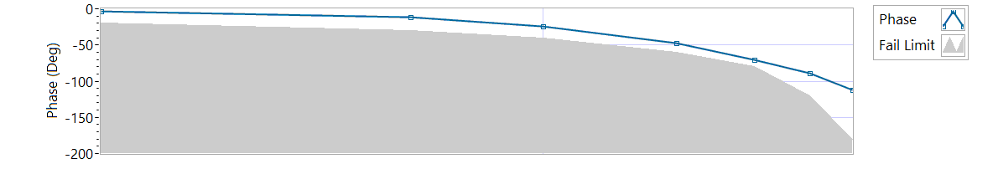

Figure - Phase for Motor Two

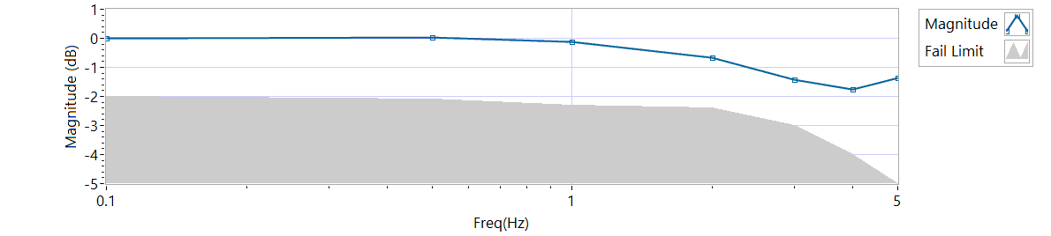

Figure - Magnitude for Motor Two

**Frequency Response**

|  |  |  |  |  |
| --- | --- | --- | --- | --- |
| **MCE 2 - Frequency Response Unloaded** | | | | |
| **Frequency (Hz)** | **Magnitude**  **(dB)** | **Phase**  **(Deg)** | **Max Phase**  **Allowance (Deg)** | **Pass/Fail** |
| 0.1 Hz | -0.00443087 | -2.9376 | -20 | Pass |
| 0.5 Hz | 0.0365077 | -11.916 | -30 | Pass |
| 1 Hz | -0.128417 | -24.444 | -40 | Pass |
| 2 Hz | -0.657599 | -47.304 | -60 | Pass |
| 3 Hz | -1.41193 | -70.308 | -80 | Pass |
| 4 Hz | -1.76718 | -88.848 | -120 | Pass |
| 5 Hz | -1.34884 | -112.5 | -180 | Pass |

6.6.7.3.1 **MCE 3 – Step Response Test**

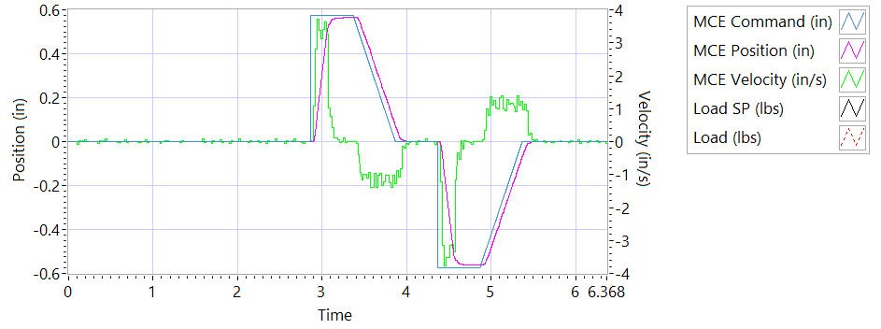

Figure - Results for Motor Three

**Step d Extension**

|  |  |  |  |
| --- | --- | --- | --- |
| **MCE 3 – Step Response Extension Unloaded** | | | |
| **Requirements** | **Results** | | |
| **Description** | **Actual Speed / Time** | **Units** | **Pass/Fail** |
| No Load speed is 2.7 to 3.3 in/sec | 3.2832 | in/s | Pass |
| Time to achieve 80% of the specified stroke (+ 0.575 ins) is 170+9/-9 ms | 0.2027 | seconds | Failed |

**Step e Retraction**

|  |  |  |  |
| --- | --- | --- | --- |
| **MCE 3 – Step Response Retraction Unloaded** | | | |
| **Requirements** | **Results** | | |
| **Description** | **Actual Speed / Time** | **Units** | **Pass/Fail** |
| No Load speed is 2.7 to 3.3 in/sec | -3.269 | in/s | Pass |
| Time to achieve 80% of the specified stroke (- 0.575 ins) is 170+9/-9 ms | 0.199 | seconds | Failed |

6.6.7.3.2 **MCE 3 Frequency Response Test**

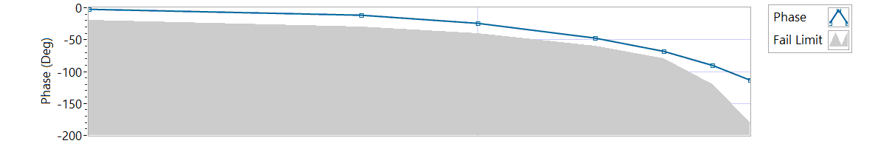

Figure - Phase for Motor Three

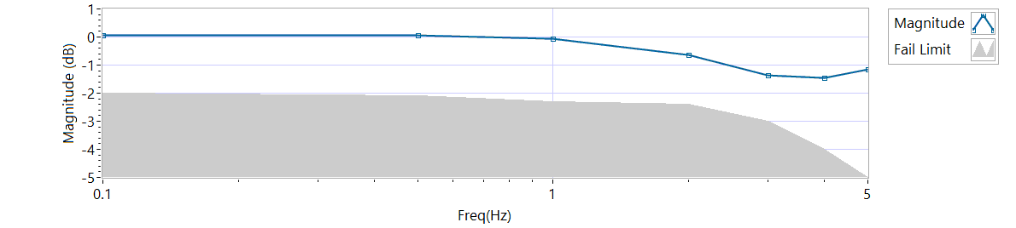

Figure - Magnitude for Motor Three

**Step d**

|  |  |  |  |  |
| --- | --- | --- | --- | --- |
| **MCE 3 Frequency Response Unloaded** | | | | |
| **Frequency**  **(Hz)** | **Magnitude**  **(dB)** | **Phase**  **(Deg)** | **Max Phase**  **Allowance (Deg)** | **Pass/Fail** |
| 0.1 Hz | 0.0636932 | -2.1924 | -20 | Pass |
| 0.5 Hz | 0.0501111 | -11.628 | -30 | Pass |
| 1 Hz | -0.0593175 | -23.94 | -40 | Pass |
| 2 Hz | -0.642865 | -47.736 | -60 | Pass |
| 3 Hz | -1.36381 | -68.58 | -80 | Pass |
| 4 Hz | -1.45986 | -90.144 | -120 | Pass |
| 5 Hz | -1.16188 | -113.4 | -180 | Pass |

**6.6.8 Performance Test – Loaded Operation**

**6.6.8.1 Step and Frequency Response Test - Loaded**

**6.6.8.1.1 MCE1 – Step Response Test**

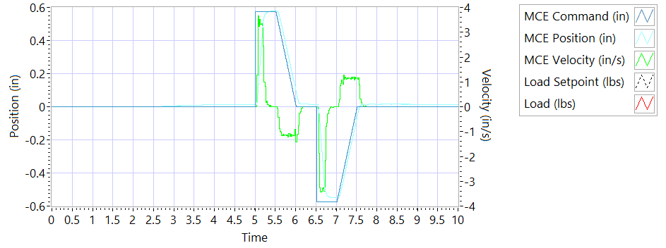

Figure - Results for Motor One Loaded

Step response Test

**Step j – 225 lbf tension - Extension**

|  |  |  |  |
| --- | --- | --- | --- |
| **MCE1 – Step Response Tension Extension** | | | |
| **Requirements** | **Results** | | |
| **Description** | **Actual Speed / Time** | **Units** | **Pass/Fail** |
| No Load speed is 2.7 to 3.3 in/sec | 3.2432 | in/s | Pass |
| Time to achieve 80% of the specified stroke (+ 0.575 ins) is 170+9/-9 ms | 0.1967 | seconds | Failed |

**Step k – 225 lbf tension - Retraction**

|  |  |  |  |
| --- | --- | --- | --- |
| **MCE1 – Step Response Tension Retraction** | | | |
| **Requirements** | **Results** | | |
| **Description** | **Actual Speed / Time** | **Units** | **Pass/Fail** |
| No Load speed is 2.7 to 3.3 in/sec | -3.2735 | in/s | Pass |
| Time to achieve 80% of the specified stroke (- 0.575 ins) is 170+9/-9 ms | 0.211 | seconds | Failed |

**Step n – 225 lbf compression - Extension**

|  |  |  |  |
| --- | --- | --- | --- |
| **MCE1 – Step Response Compression Extension** | | | |
| **Requirements** | **Results** | | |
| **Description** | **Actual Speed / Time** | **Units** | **Pass/Fail** |
| No Load speed is 2.7 to 3.3 in/sec | 3.1563 | in/s | Pass |
| Time to achieve 80% of the specified stroke (+0.575 ins) is 170+9/-9 ms | 0.2131 | seconds | Failed |

**Step o – 225 lbf compression - Retraction**

|  |  |  |  |
| --- | --- | --- | --- |
| **MCE1 – Step Response Compression Retraction** | | | |
| **Requirements** | **Results** | | |
| **Description** | **Actual Speed / Time** | **Units** | **Pass/Fail** |
| No Load speed is 2.7 to 3.3 in/sec | -3.2365 | in/s | Pass |
| Time to achieve 80% of the specified stroke (-0.575 ins) is 170+9/-9 ms | 0.1906 | seconds | Failed |

**6.6.8.1.2 MCE 1 – Frequency Response Test**

**Step d – 225 lbf Tension**

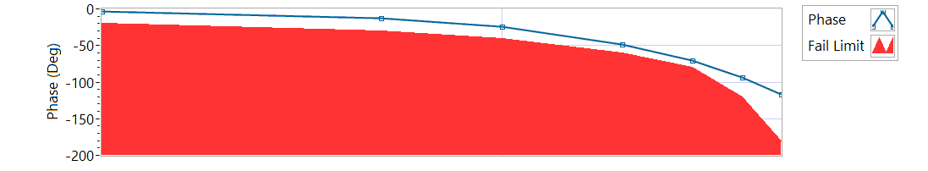

Figure - Phase for Motor One Loaded Tension

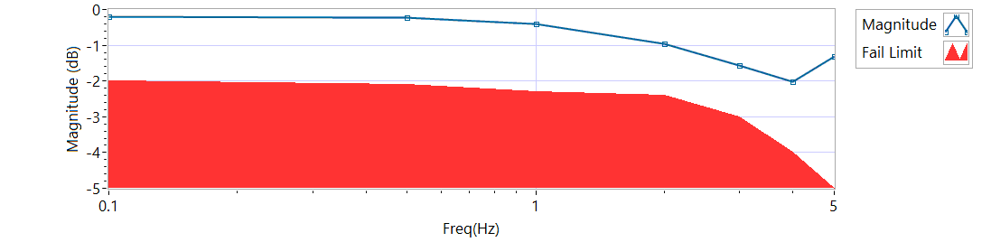

Figure - Magnitude for Motor One Loaded Tension

|  |  |  |  |  |
| --- | --- | --- | --- | --- |
| **MCE 1 – Tension Frequency Response** | | | | |
| **Frequency**  **(Hz)** | **Magnitude**  **(dB)** | **Phase**  **(Deg)** | **Max Phase**  **Allowance (Deg)** | **Pass/Fail** |
| 0.1 HZ | -0.198073 | -2.9628 | -20 | Pass |
| 0.5 HZ | -0.226092 | -12.708 | -30 | Pass |
| 1 HZ | -0.396132 | -24.624 | -40 | Pass |
| 2 HZ | -0.957659 | -48.312 | -60 | Pass |
| 3 HZ | -1.55792 | -71.064 | -80 | Pass |
| 4 HZ | -2.03083 | -93.744 | -120 | Pass |
| 5 HZ | -1.31155 | -116.82 | -180 | Pass |

**Step h – 225 lbf Compression**

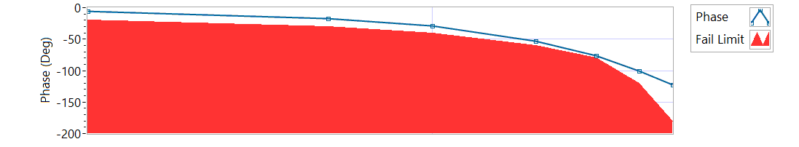

Figure - Phase for Motor One Loaded Compression

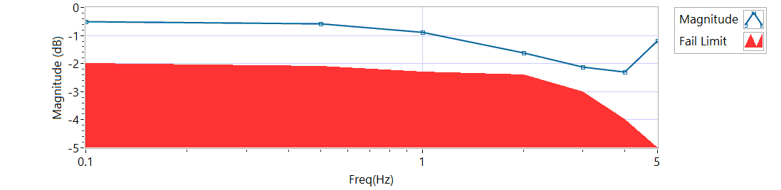

Figure - Magnitude for Motor One Loaded Compression

|  |  |  |  |  |
| --- | --- | --- | --- | --- |
| **MCE 1 – Compression Frequency Response** | | | | |
| **Frequency**  **(Hz)** | **Magnitude**  **(dB)** | **Phase**  **(Deg)** | **Max Phase**  **Allowance (Deg)** | **Pass/Fail** |
| 0.1 HZ | -0.511368 | -6.0768 | -20 | Pass |
| 0.5 HZ | -0.569564 | -16.866 | -30 | Pass |
| 1 HZ | -0.881667 | -29.268 | -40 | Pass |
| 2 HZ | -1.60723 | -53.568 | -60 | Pass |
| 3 HZ | -2.11522 | -76.68 | -80 | Pass |
| 4 HZ | -2.29332 | -100.8 | -120 | Pass |
| 5 HZ | -1.19882 | -122.58 | -180 | Pass |

**6.6.8.2.1 MCE 2 – Step Response Test**

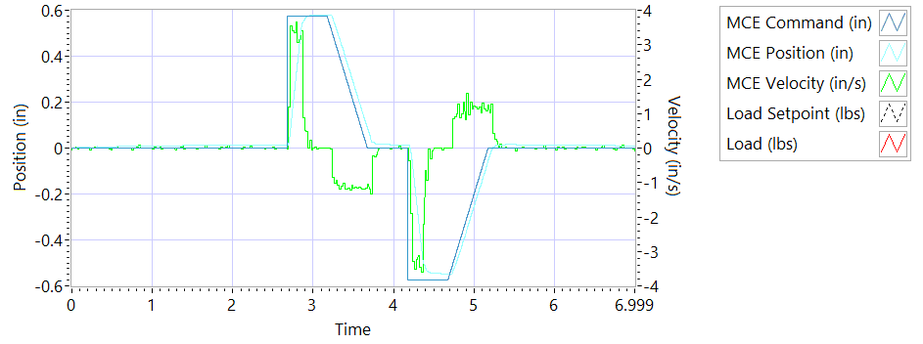

Figure - Results for Motor Two Loaded Tension

**Step j – 225 lbf tension - Extension**

|  |  |  |  |
| --- | --- | --- | --- |
| **MCE2 – Step Response Tension Extension** | | | |
| **Requirements** | **Results** | | |
| **Description** | **Actual Speed / Time** | **Units** | **Pass/Fail** |
| No Load speed is 2.7 to 3.3 in/sec | 3.2757 | in/s | Pass |
| Time to achieve 80% of the specified stroke (+ 0.575 ins) is 170+9/-9 ms | 0.1874 | seconds | Failed |

**Step k – 225 lbf tension - Retraction**

|  |  |  |  |
| --- | --- | --- | --- |
| **MCE2 – Step Response Tension Retraction** | | | |
| **Requirements** | **Results** | | |
| **Description** | **Actual Speed / Time** | **Units** | **Pass/Fail** |
| No Load speed is 2.7 to 3.3 in/sec | -3.2964 | in/s | Pass |
| Time to achieve 80% of the specified stroke (- 0.575 ins) is 170+9/-9 ms | 0.1994 | seconds | Failed |

**Step n – 225 lbf compression - Extension**

|  |  |  |  |
| --- | --- | --- | --- |
| **MCE2 – Step Response Compression Extension** | | | |
| **Requirements** | **Results** | | |
| **Description** | **Actual Speed / Time** | **Units** | **Pass/Fail** |
| No Load speed is 2.7 to 3.3 in/sec | 3.2933 | in/s | Pass |
| Time to achieve 80% of the specified stroke (+0.575 ins) is 170+9/-9 ms | 0.2257 | seconds | Failed |

**Step o – 225 lbf compression - Retraction**

|  |  |  |  |
| --- | --- | --- | --- |
| **MCE2 – Step Response Compression Retraction** | | | |
| **Requirements** | **Results** | | |
| **Description** | **Actual Speed / Time** | **Units** | **Pass/Fail** |
| No Load speed is 2.7 to 3.3 in/sec | -3.2262 | in/s | Pass |
| Time to achieve 80% of the specified stroke (-0.575 ins) is 170+9/-9 ms | 0.2137 | seconds | Failed |

**6.6.8.2.2 MCE 2 – Frequency response Test**

**Step d – 225 lbf Tension**

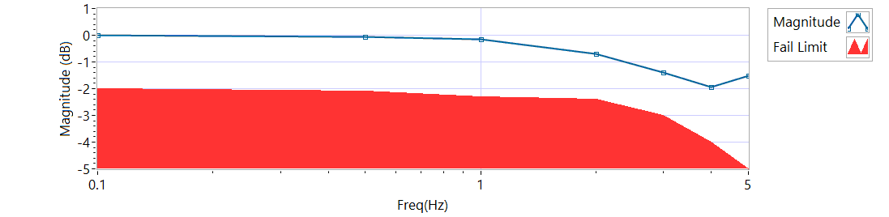

Figure - Magnitude for Motor Two Loaded Tension

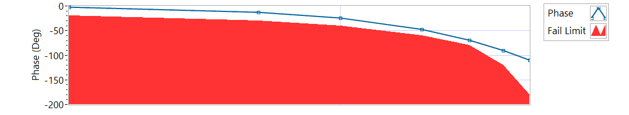

Figure - Phase for Motor Two Loaded Tension

|  |  |  |  |  |
| --- | --- | --- | --- | --- |
| **MCE 2 – Frequency response Tension** | | | | |
| **Frequency**  **(Hz)** | **Magnitude**  **(dB)** | **Phase**  **(Deg)** | **Max Phase**  **Allowance (Deg)** | **Pass/Fail** |
| 0.1 HZ | 0.00923677 | -2.322 | -20 | Pass |
| 0.5 HZ | -0.0730961 | -12.222 | -30 | Pass |
| 1 HZ | -0.156214 | -24.12 | -40 | Pass |
| 2 HZ | -0.687143 | -47.304 | -60 | Pass |
| 3 HZ | -1.39586 | -69.876 | -80 | Pass |
| 4 HZ | -1.9409 | -90.72 | -120 | Pass |
| 5 HZ | -1.51541 | -110.34 | -180 | Pass |

**Step h – 225 lbf Compression**

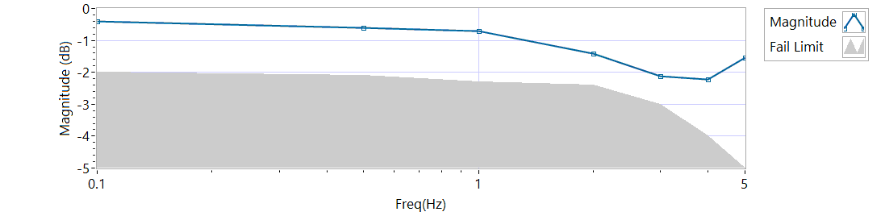

Figure - Magnitude for Motor Two Loaded Compression

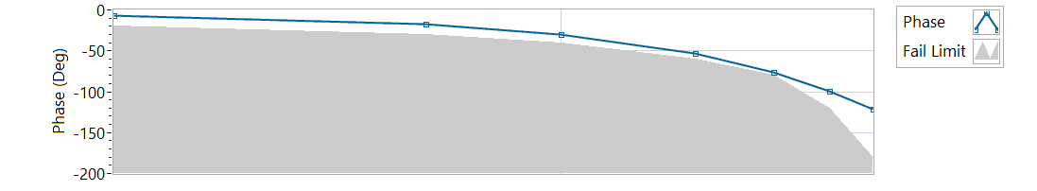

Figure - Phase for Motor Two Loaded Compression

|  |  |  |  |  |
| --- | --- | --- | --- | --- |
| **MCE 2 – Frequency response Compression** | | | | |
| **Frequency**  **(Hz)** | **Magnitude**  **(dB)** | **Phase**  **(Deg)** | **Max Phase**  **Allowance (Deg)** | **Pass/Fail** |
| 0.1 HZ | -0.410452 | -6.6816 | -20 | Pass |
| 0.5 HZ | -0.59881 | -17.406 | -30 | Pass |
| 1 HZ | -0.701954 | -29.484 | -40 | Pass |
| 2 HZ | -1.41203 | -53.712 | -60 | Pass |
| 3 HZ | -2.11514 | -76.572 | -80 | Pass |
| 4 HZ | -2.21388 | -98.928 | -120 | Pass |
| 5 HZ | -1.55051 | -120.96 | -180 | Pass |

**6.6.8.3.1 MCE 3 – Step Response Test**

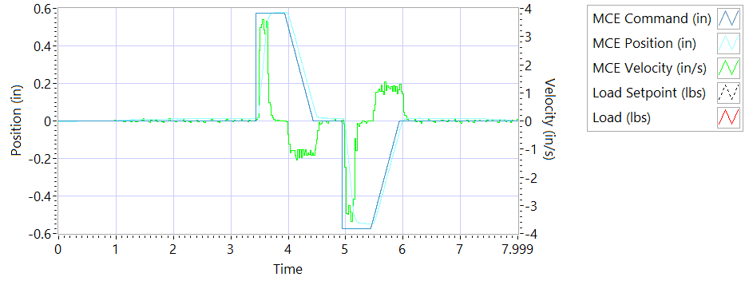

Figure - Results for Motor Three

**Step j – 225 lbf tension - Extension**

|  |  |  |  |
| --- | --- | --- | --- |
| **MCE3 – Step Response Tension Extension** | | | |
| **Requirements** | **Results** | | |
| **Description** | **Actual Speed / Time** | **Units** | **Pass/Fail** |
| No Load speed is 2.7 to 3.3 in/sec | 3.268 | in/s | Pass |
| Time to achieve 80% of the specified stroke (+ 0.575 ins) is 170+9/-9 ms | 0.2061 | seconds | Failed |

**Step k – 225 lbf tension - Retraction**

|  |  |  |  |
| --- | --- | --- | --- |
| **MCE3 – Step Response Tension Retraction** | | | |
| **Requirements** | **Results** | | |
| **Description** | **Actual Speed / Time** | **Units** | **Pass/Fail** |
| No Load speed is 2.7 to 3.3 in/sec | -3.269 | in/s | Pass |
| Time to achieve 80% of the specified stroke (- 0.575 ins) is 170+9/-9 ms | 0.2122 | seconds | Failed |

**Step n – 225 lbf compression - Extension**

|  |  |  |  |
| --- | --- | --- | --- |
| **MCE3 – Step Response Compression Extension** | | | |
| **Requirements** | **Results** | | |
| **Description** | **Actual Speed / Time** | **Units** | **Pass/Fail** |
| No Load speed is 2.7 to 3.3 in/sec | 3.3018 | in/s | Pass |
| Time to achieve 80% of the specified stroke (+0.575 ins) is 170+9/-9 ms | 0.2108 | seconds | Failed |

**Step o – 225 lbf compression - Retraction**

|  |  |  |  |
| --- | --- | --- | --- |
| **MCE3 – Step Response Compression Retraction** | | | |
| **Requirements** | **Results** | | |
| **Description** | **Actual Speed / Time** | **Units** | **Pass/Fail** |
| No Load speed is 2.7 to 3.3 in/sec | -3.2303 | in/s | Pass |
| Time to achieve 80% of the specified stroke (-0.575 ins) is 170+9/-9 ms | 0.2013 | seconds | Failed |

**6.6.8.3.2 MCE 3 – Frequency Response Test**

**Step d – 225 lbf Tension**

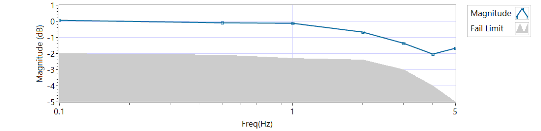

Figure - Magnitude for Motor Three Loaded Tension

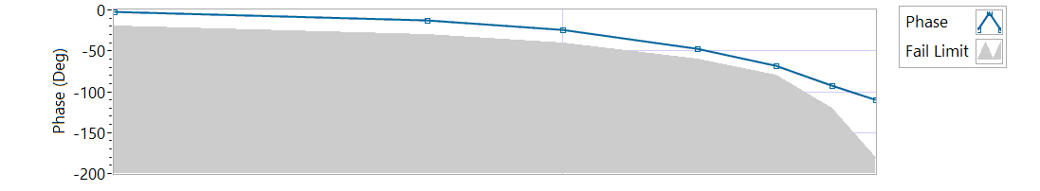

Figure - Phase for Motor Three Loaded Tension

|  |  |  |  |  |
| --- | --- | --- | --- | --- |
| **MCE 3 – Tension Frequency Response** | | | | |
| **Frequency**  **(Hz)** | **Magnitude**  **(dB)** | **Phase**  **(Deg)** | **Max Phase**  **Allowance (Deg)** | **Pass/Fail** |
| 0.1 HZ | 0.0636958 | -2.2284 | -20 | Pass |
| 0.5 HZ | -0.086894 | -12.168 | -30 | Pass |
| 1 HZ | -0.12842 | -24.372 | -40 | Pass |
| 2 HZ | -0.672358 | -47.376 | -60 | Pass |
| 3 HZ | -1.36381 | -68.364 | -80 | Pass |
| 4 HZ | -2.02908 | -92.304 | -120 | Pass |
| 5 HZ | -1.659 | -110.16 | -180 | Pass |

**Step h – 225 lbf Compression**

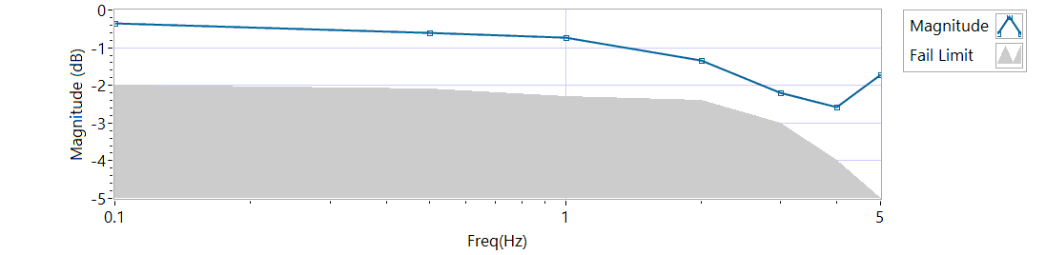

Figure - Magnitude for Motor Three Loaded Compression

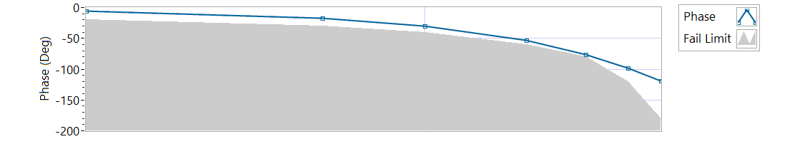

Figure - Phase for Motor Three Loaded Compression

|  |  |  |  |  |
| --- | --- | --- | --- | --- |
| **MCE 3 – Compression Frequency Response** | | | | |
| **Frequency**  **(Hz)** | **Magnitude**  **(dB)** | **Phase**  **(Deg)** | **Max Phase**  **Allowance (Deg)** | **Pass/Fail** |
| 0.1 HZ | -0.35331 | -6.3108 | -20 | Pass |
| 0.5 HZ | -0.61347 | -17.874 | -30 | Pass |
| 1 HZ | -0.73165 | -29.772 | -40 | Pass |
| 2 HZ | -1.34793 | -53.352 | -60 | Pass |
| 3 HZ | -2.18473 | -76.356 | -80 | Pass |
| 4 HZ | -2.57715 | -98.352 | -120 | Pass |
| 5 HZ | -1.71731 | -118.98 | -180 | Pass |

**6.6.9 Backlash**

6.6.9.1 **Simplex Brake 1 – ON; Duplex brake 2 – OFF**

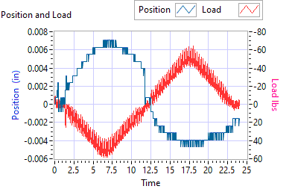

Figure - Backlash Simplex brake 1 On, Duplex brake 2 Off

|  |  |  |  |  |  |
| --- | --- | --- | --- | --- | --- |
| **Simplex Brake 1 – ON; Duplex brake 2 – OFF** | | | | | |
| **Requirements** | | | **Results** | | |
| **Step** | **Expected** | **Tolerance** | **Actual** | **Units** | **Pass/Fail** |
| Step e 35 lbf tension (Motor 2 and Motor 3 zero position) | 0.0144 | 0.005 | 0.0071 | in | Pass |
| 35 | 5 | 51.2624 | lbf | Pass |
| Step e -35 lbf compression (Motor 2 and Motor 3 zero position) | 0.0144 | 0.005 | -0.0039 | in | Pass |
| 35 | 5 | -49.1514 | lbf | Pass |

6.6.9.2**Simplex Brake 1 – OFF; Duplex Brake 2 – ON**

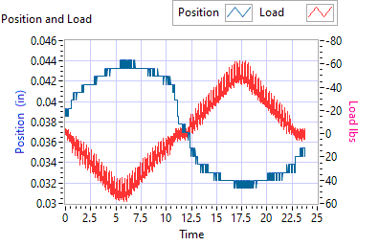

Figure - Backlash Simplex brake 1 Off, Duplex brake 2 On

|  |  |  |  |  |  |
| --- | --- | --- | --- | --- | --- |
| **Simplex Brake 1 – OFF; Duplex Brake 2 – ON** | | | | | |
| **Requirements** | | | **Results** | | |
| **Step** | **Expected** | **Tolerance** | **Actual** | **Units** | **Pass/Fail** |
| Step e 35 lbf tension  (Motor 1 zero position) | 0.0144 | 0.005 | 0.0441 | in | Pass |
| 35 | 5 | 54.6753 | lbf | Pass |
| Step e -35 lbf compression  (Motor 1 zero position) | 0.0144 | 0.005 | 0.0315 | in | Pass |
| -35 | 5 | -55.541 | lbf | Pass |

6.6.9.3 **Both Brakes OFF**

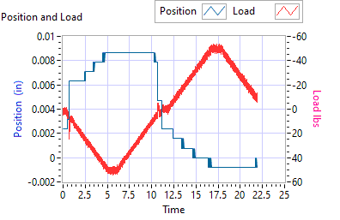

Figure - Backlash Simplex brake 1 Off, Duplex brake 2 Off

|  |  |  |  |  |  |
| --- | --- | --- | --- | --- | --- |
| **Both Brakes OFF** | | | | | |
| **Requirements** | | | **Results** | | |
| **Step** | **Expected** | **Tolerance** | **Actual** | **Units** | **Pass/Fail** |
| Step e 35 lbf tension  (Motor 1 and Motor 2 holding zero position) | 0.0144 | 0.005 | 0.0087 | in | Pass |
| 35 | 5 | 50.9357 | lbf | Pass |
| Step e -35 lbf compression  (Motor 1 and Motor 2 holding zero position) | 0.0144 | 0.005 | -0.0008 | in | Pass |
| -35 | 5 | -50.2334 | lbf | Pass |